In the first week of class, our group of four people completed and recorded the stakeholder register, the mutual interests of the four characters, were downloaded and learned to use git.In the second week of class, we learned the software development model and created a table.In the third week of class, we learned and learned about five of the most popular agile methods in the IT industry and learned about their main differences.

The four people of our group have a clear division of labor when completing the task. The specific content is completed by two people. The other two people evaluate and put forward suggestions on the task, and then modify the task for the second time and submit it.Viable action is that the members of the group actively put forward opinions. Unfeasible action is not efficient in the process of completing tasks. What needs improvement in the future is to improve efficiency and strengthen cooperation within the group.

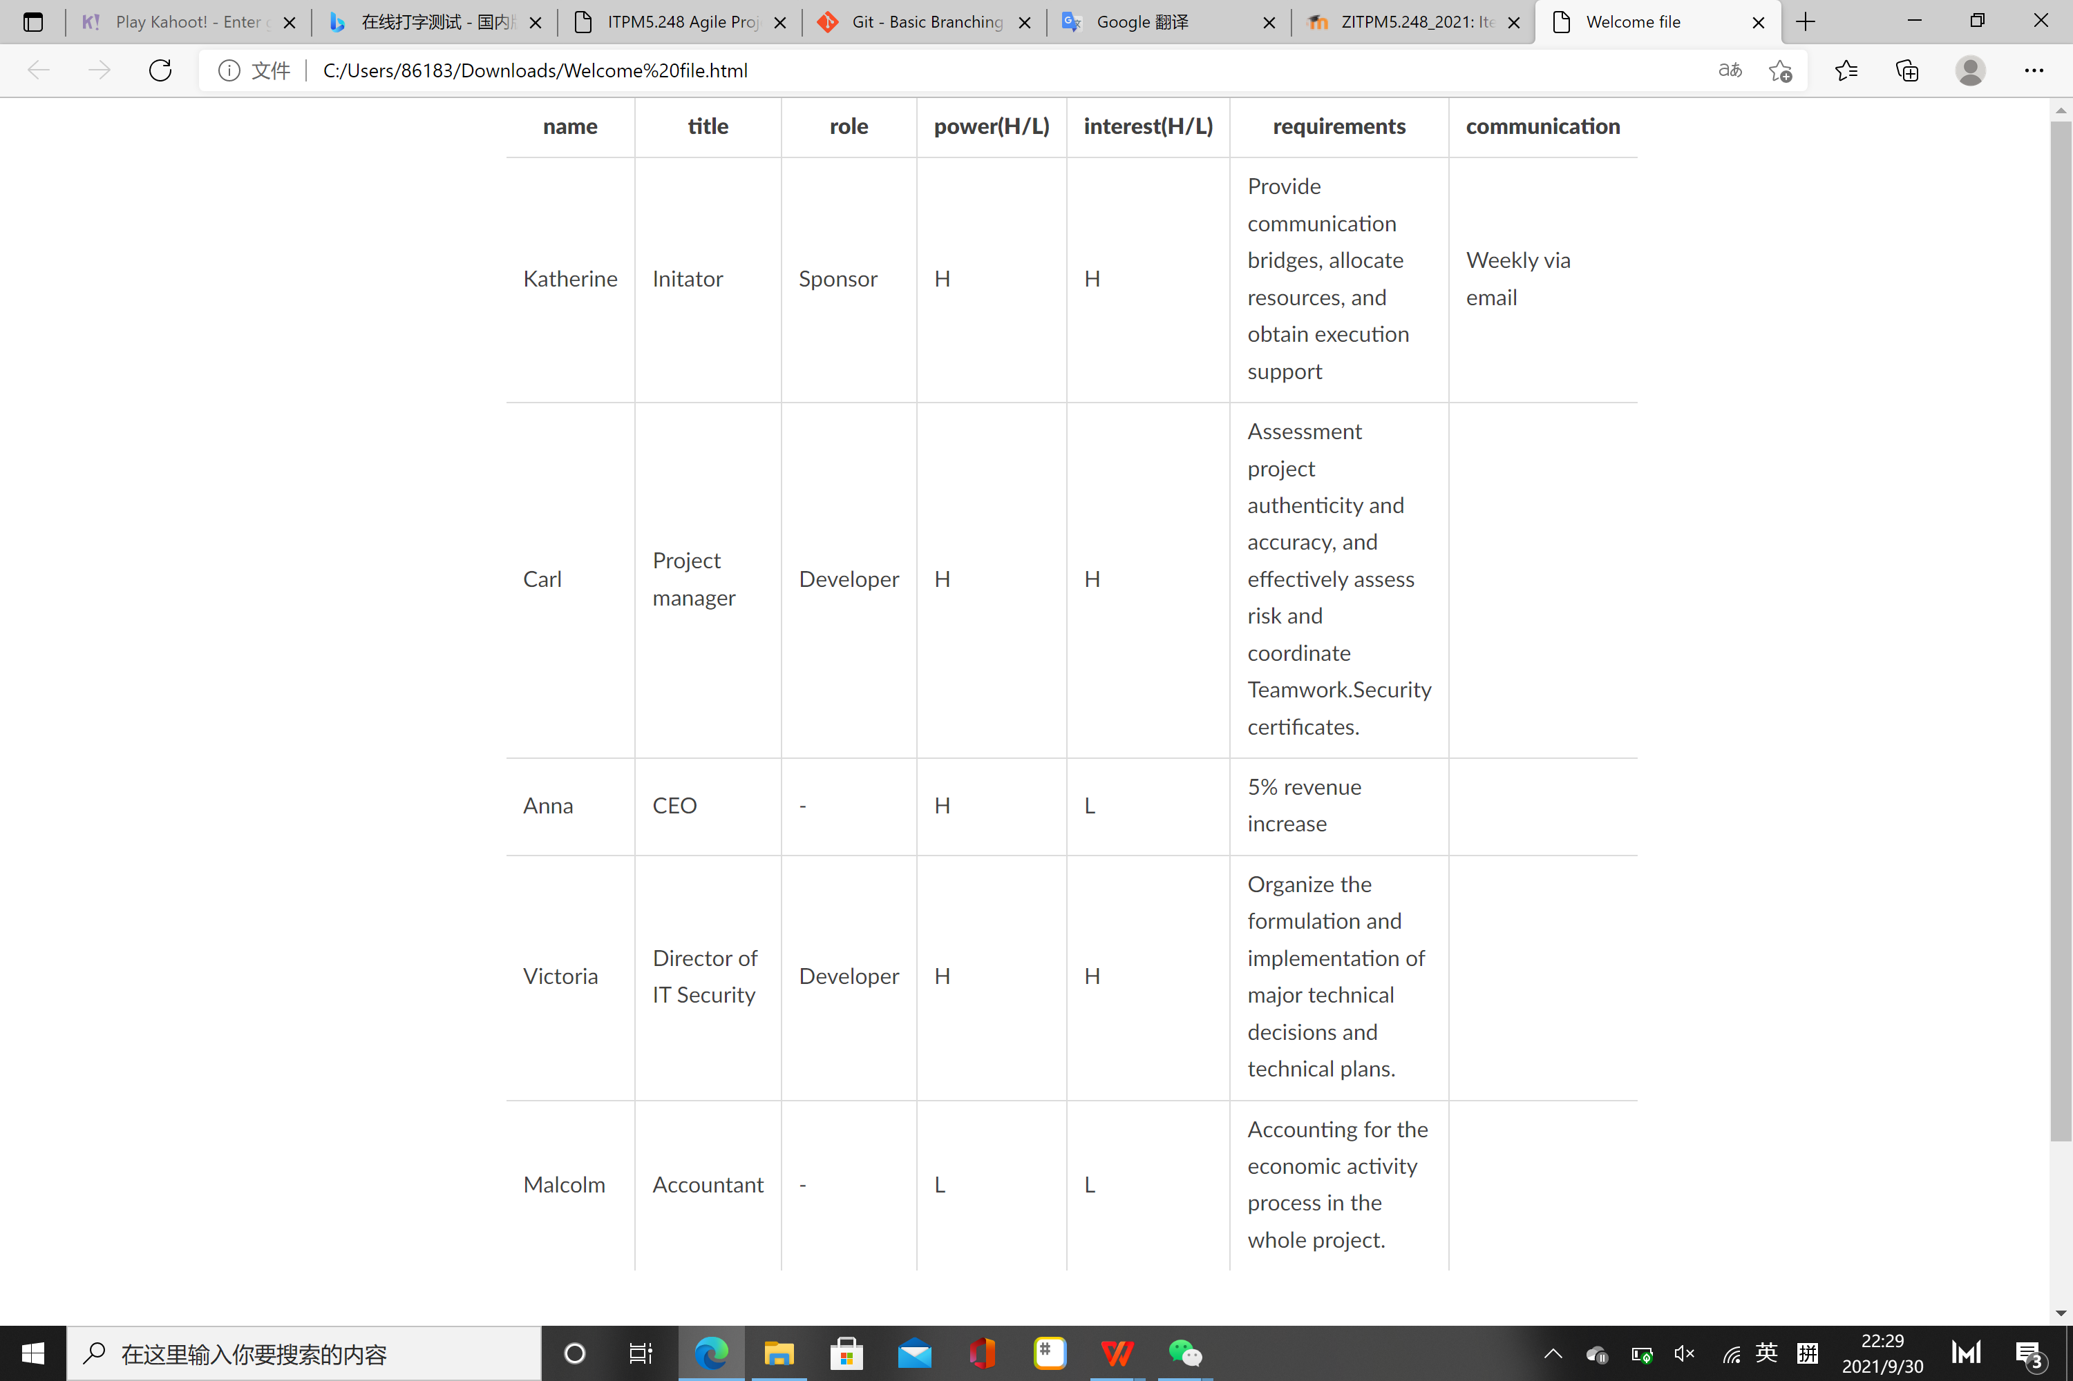

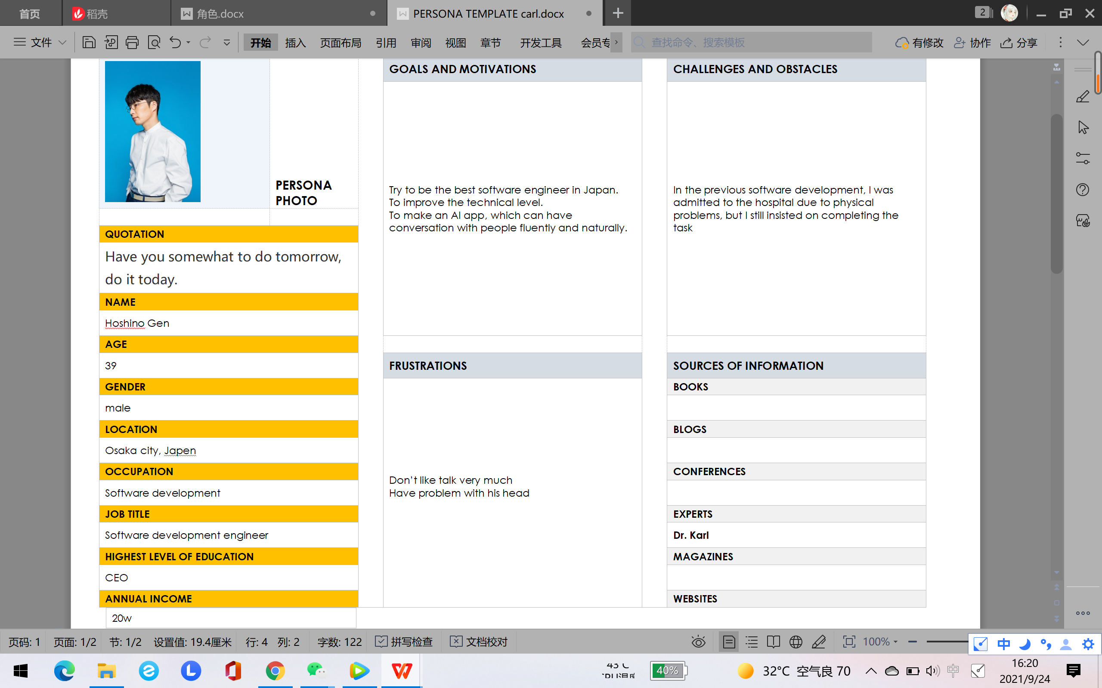

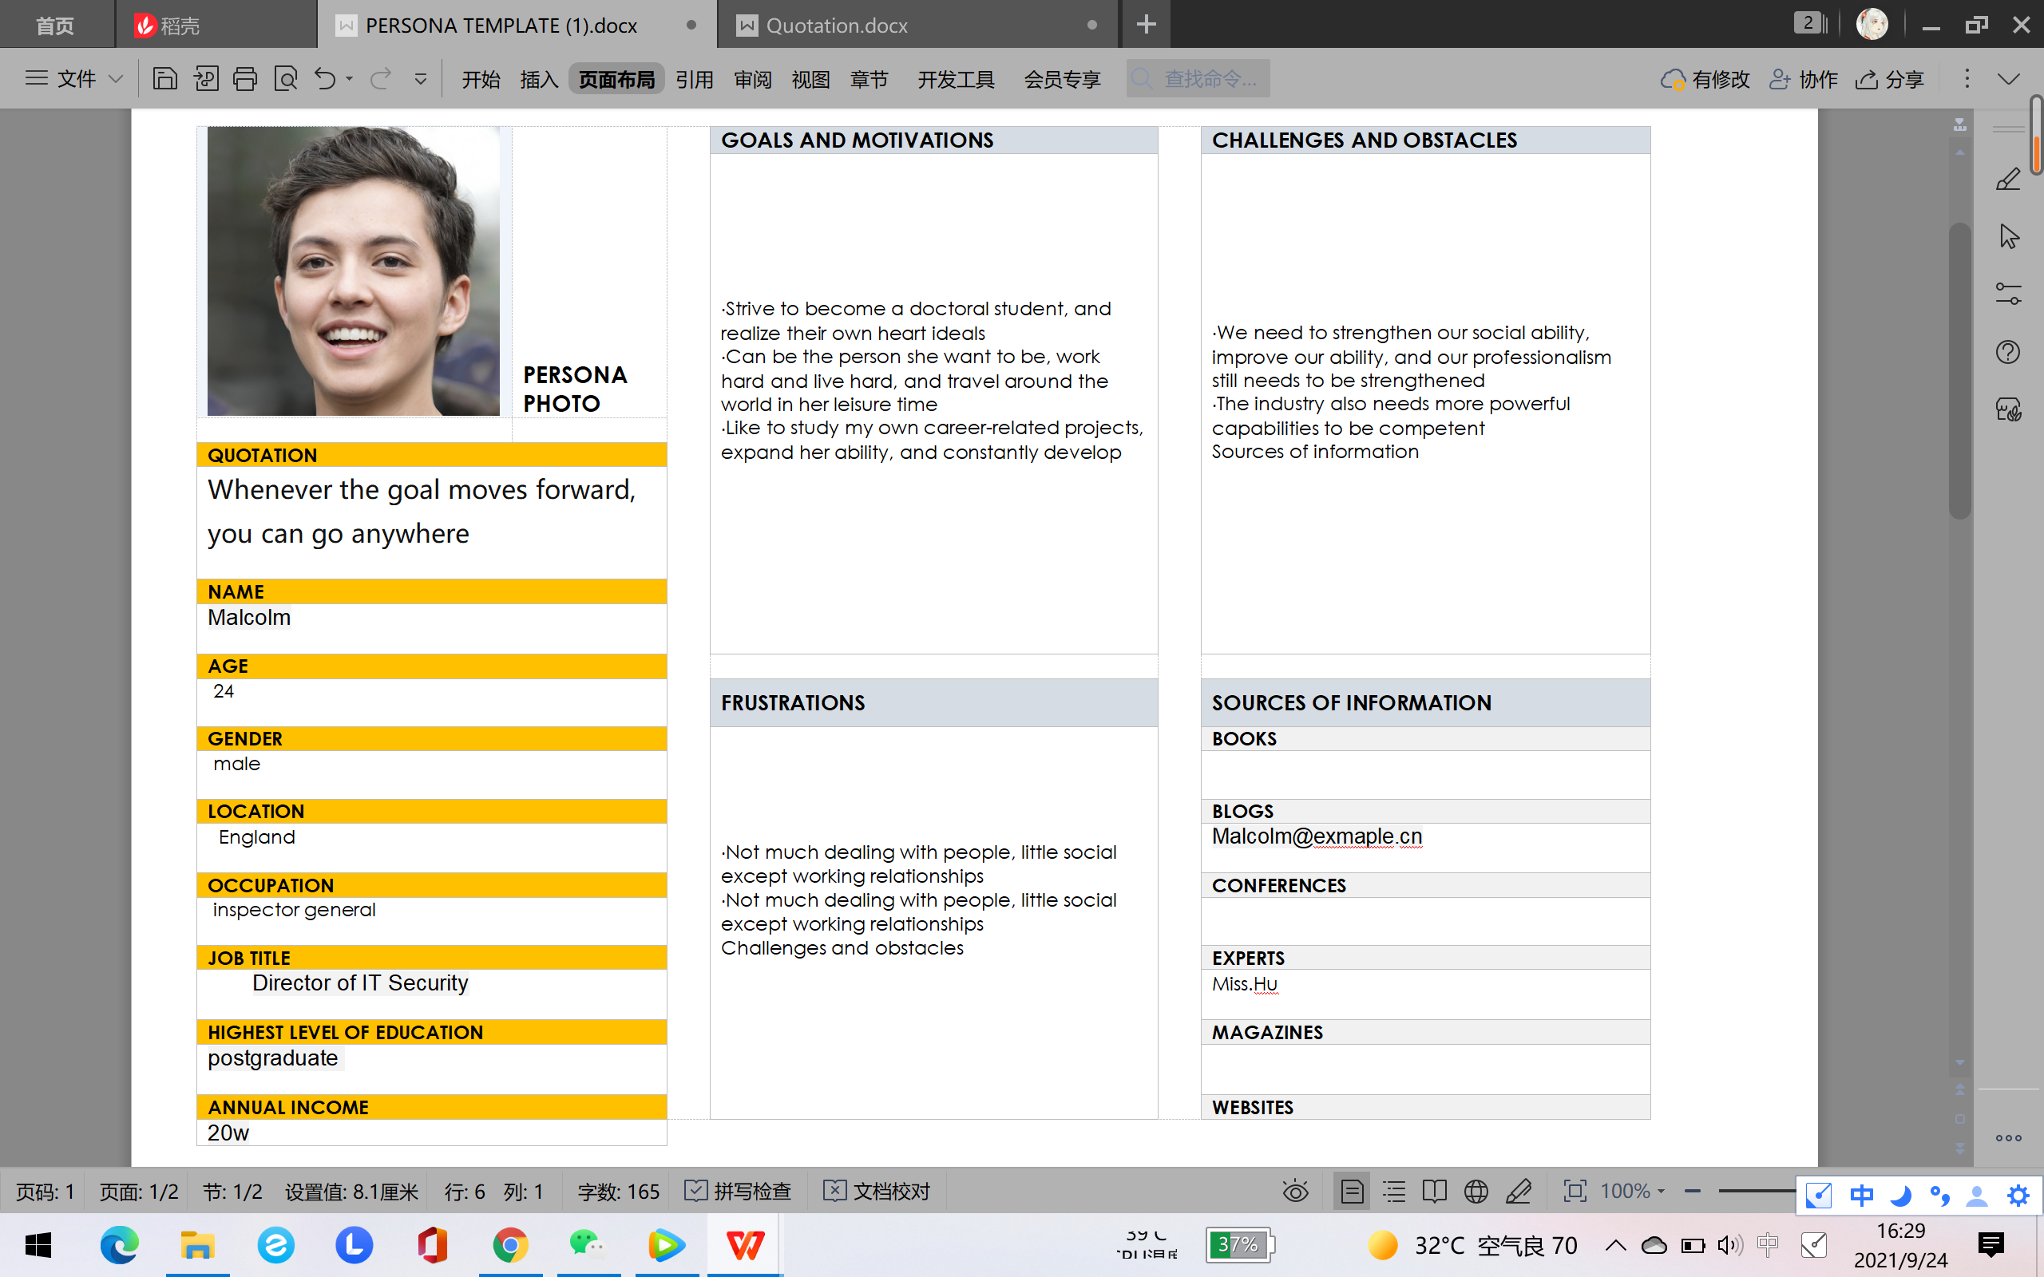

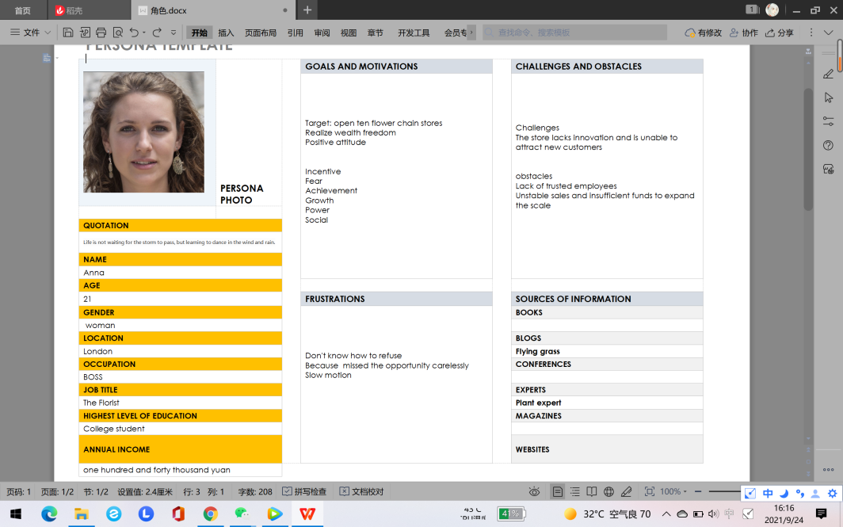

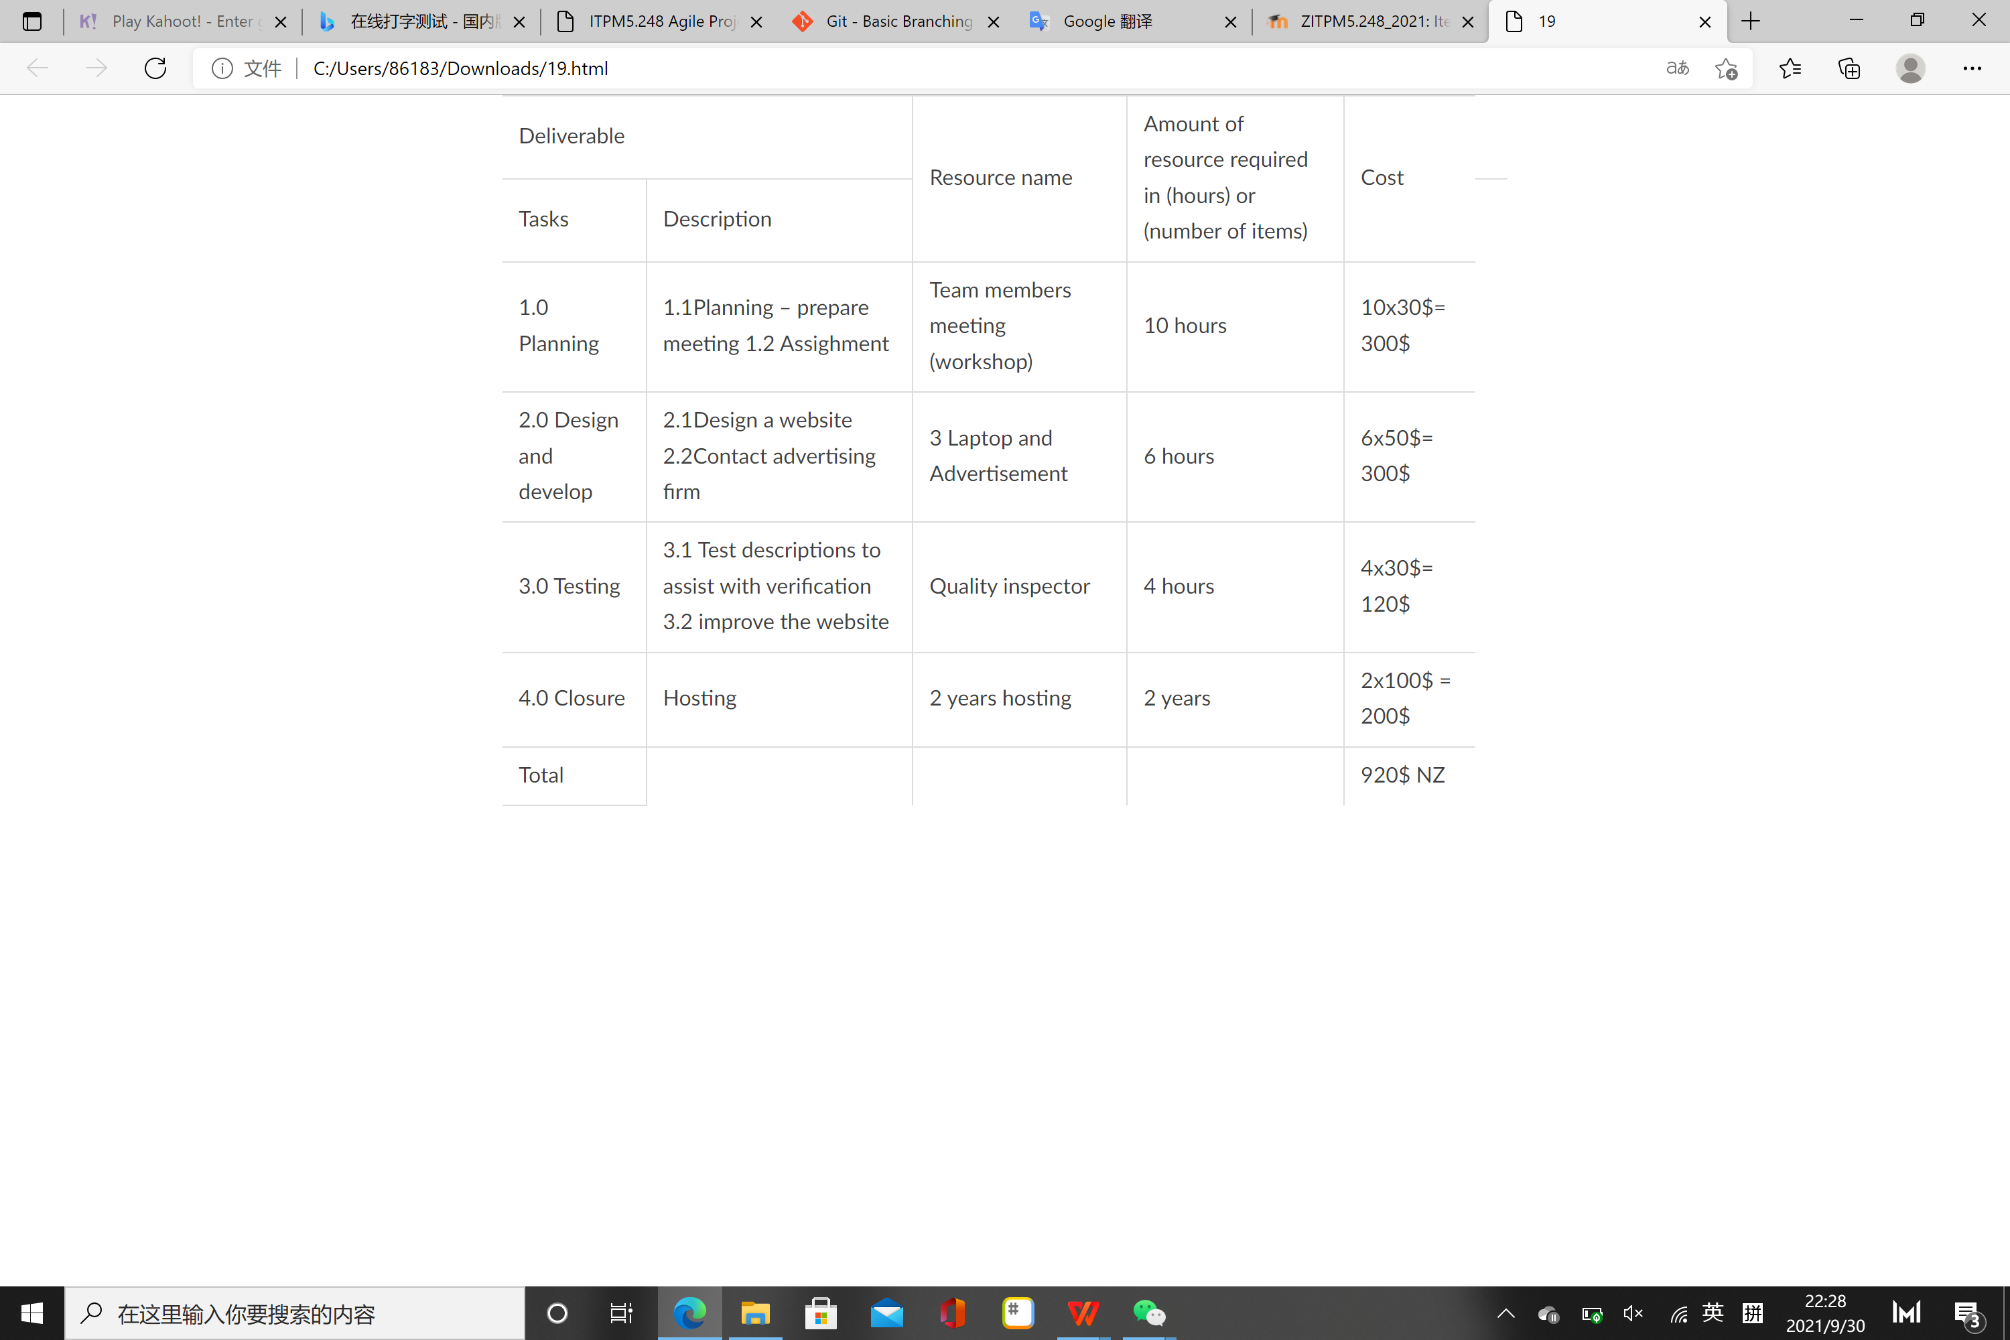

Group19

Anna Katherine Cral Viictoria